Dear Friends, Employees, and Family,

You’d be forgiven for losing a little heart these days. The damage and distress COVID-19 inflicts on our collective health and well-being is alarming. COVID-19 cases are surging in California, leading to closure of whole business sectors. Santa Cruz County has, so far, had lower transmission than other California counties and because of this we have not yet had to fully roll back our reopening. The era of COVID-19 will eventually end--and the choices we make to protect ourselves and others will see us through.

80% of our state’s population lives in counties placed on the monitoring watch list where tighter restrictions are mandated. Now, we find ourselves on the wrong slope of a new curve, in danger of joining other regions taking more painful economic measures.

Almost all transmission in our county has been linked to social activities--specifically to people having close contact without masks with members of other households, sometimes at work, but mostly at home or at social gatherings. In fact, COVID infections among co-workers have typically been through after hours parties or through extended break room conversations.

In order to protect all of our jobs, our health, and allow us to re-open schools, we need everyone to choose to meet friends and family, if they do so, in ways that won't spread the virus.

Believe in Action
We must continue to stand strong against COVID-19. The good news is we know how to do it. Dr. Marm Kilpatrick, an infectious disease specialist at UC Santa Cruz, has used the most current scientific data about case transmission to develop these four easy to follow guidelines to keep us safer.

- Protected (wear a mask)
- Spatially distant (at least 6 feet apart)
- Well ventilated (outside is best)
- Brief (keep interactions under 10-15 minutes)

If you are going to meet a person that you don't live with, it’s safest to meet them outside, with space between you, and if it's hard to have at least 6' of space, wear a mask. If you have to meet someone indoors please keep it very brief, wear a mask, and, if possible, keep at least 6' between you and them and open a window or make sure there is plenty of ventilation. We know that some of your interactions may not be brief, so please make sure that the other 3 precautions are in place. Likewise, we know that you can’t always be outside, so please make sure you do the other 3.

If we don't make these small adjustments to how we meet people we are going to have to close businesses and lose many jobs and experience even more difficulty than we already have as a community. Even for those of us who are young and healthy and are less likely to get very sick, we need to take these simple actions to protect aunts, grandparents, uncles, parents and those with underlying health conditions.

The only way we can stop the pandemic is to take control ourselves and the sacrifice isn't that big. We just need to meet outside, give space, and wear a mask.

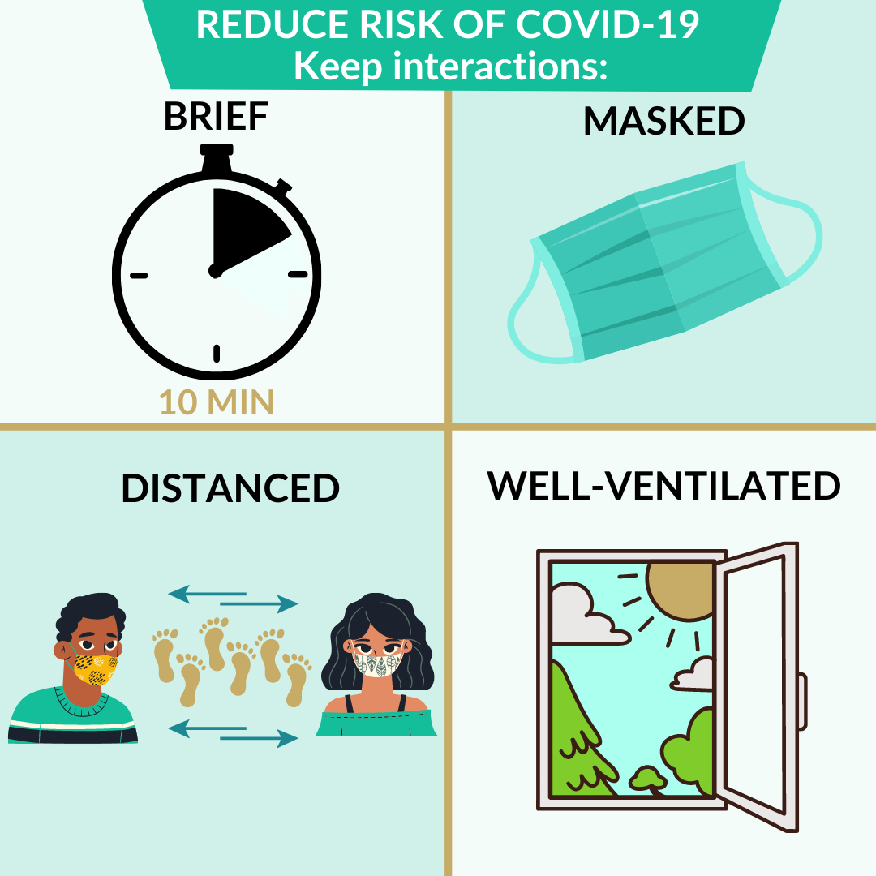

Spread Something Helpful
Sharing accurate safety information with colleagues, family members, and community connections is essential. The health of all of us, depends on the health of each of us.

Know someone who could use a reminder? Please consider sharing this letter as a blog post: "Easy Steps to Reduce Risk" or graphic with these easy to understand guidelines for reducing transmission of COVID-19.

So take heart, stay safe, stay hopeful (and stay masked and distanced, if you aren’t home!)

We can do this,

BUSINESS LEADER NAME

